**Lab 9: If-else statement and conditions**

**Note:** In all the lab tasks below, you should exit the program by showing an appropriate message, if the input failure occurs.

**Lab Task 1.**

**Program Name: (The number-word program 0-9)**

**Purpose:** apply if-else-if (or nested if-else) statement

**Problem Statement:** Write a program which inputs a one digit number from the user (i.e. 0-9). The program should them print that number in words, e.g. “Zero” for 0, “One” for 1, “Two” for 2, and so on. If the user does not enter a one-digit number, then program should display an error: “Invalid number!”

**Output**

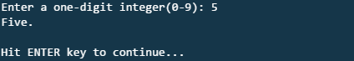

**Home Task 1.**

**Program Name: (The extended number-word program 0-99)**

**Purpose:** apply if-else-if (or nested if-else) statement

**Problem Statement:** Write a program to extend that of the above Lab Task, so that it handles two-digit numbers, i.e. numbers from 0 to 99.

**HINT:** use division and modulus operators to separate the two digits, e.g. ‘5’ and ‘8’ in ‘58’. Then, left digit translates to tenth count, e.g. ‘Fifty ’, and right digit translates to single digit [as in the above Lab Task], e.g. ‘eight’. If the right digit is 0, no need to show anything, e.g. “Twenty” for 20. Note that this solution applies to numbers from 20-99. For numbers from 0-19, you need to write 20 conditions, separately.

**Lab Task 2.**

**Program Name: (The triangle type program)**

**Purpose: apply logical operators in conjunction with the nested if-else statement**

**Problem Statement:** If the three sides of a triangle are entered through the keyboard, write a program to check whether the triangle is a right-angled triangle or not. The sample output is given below.

**HINT:** Note that the user does not have to specify exactly which side is base, perpendicular or hypotenuses. This means that you will have to check for all possible combinations of the 3 sides to determine whether it is a right-angle triangle or not. If any combination satisfies the condition of right-angle triangle ( side1 = sqrt(side22 + side32) ), then it’s a right angled triangle. Use sqrt function from CMATH header file for computing the square root of a number.

**Output**

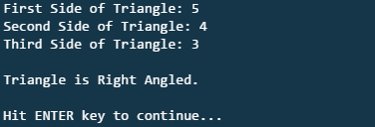

**Home Task 2:** Convert the above program to handle triangles of other types, e.g. isosceles, equilateral and scalene triangle. Your program should be able to input the 3 sides of the triangle and display the appropriate type(s) of the triangle.

**Lab Task 3.**

The program should output the weight status based on the BMI value computed using the above formula.

**Practice Task 1.**

**Hint:** you can use the range of ascii codes of upper case letters for testing that the input is an upper case letter or not.